- What is object technology? What do you perceive as object technology’s strength? It’s weakness?
OOT is such a technology that facing the objective world and the question realm and using the generally thinking way of human-beings to acknowledge the nature world to describe some things.
OOT fit the thinking way of human-beings and easy to protect and functions’ addition and decrease are also become more convenient. And OOT’s reusing is more strengthen.
weakness

2. What is UML? List at least three benefits of developing with UML.
UML（Unified Modeling Language）is used to proceeding the visual model of software dense system.
- UML can help to express things exactly.
- UML can help programmer to write a better code.
- UML can accelerate the procedure’s development.

- What process characteristic best fit the UML? Describe each characteristic.

- What is a use-case driven process? What is use-case? What are the benefits of use case?
It is the use-case become a guidance of program.
Use-case is a description of system functions.
Use-case can help us to get a general impression of the determined system.

- What is system’s architecture? What is an architecture-centric Process?
System’s architecture is an overall construction of a system, it include the concept, the requirements and all of the detail in implementing the project. The architecture-centric process is a process that exploit a software use the system’s architecture.

- What is iteration? What are the benefits of Iterative Development?
Iteration is a way of exploiting the software that finishing the software in several steps, and it need the customer present his advices after every step in order to ensure the product can fit to the requirements of the customer’s. Iteration can ensure a lower risk in a large project.
- What are the basic principles of OO technology? Describe each in detail.
Abstraction, it report those important properties connect to the applications.
Encapsulation, it can cover details of implementation and is the basis of the modularity.
Modularity, it break complex part into simple pieces
Hierarchy, it provides a method that can let the son class to get data from father class.

- What is use case model? Which artifacts can be included in a use case model?

- List three types of relationships existed between different use cases and give examples.
Generalization, Include, Extend.
Generalization, apples and bananas can be generalized as fruit.
Include, the banana peel is included in the banana.
Extend, we can eat the banana, but we can also smash it and mixed it with yogurt and drink it, drinking is an extension.

- Explain the following diagram and their elements with examples.
1) Use case diagram 2) Activity diagram 3) Sequence diagram 4) Collaboration diagram
5) Class diagram 6) state chart diagram 7) Deployment diagram
1) 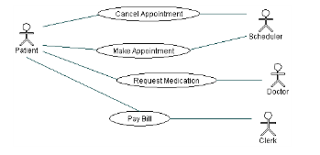
2) 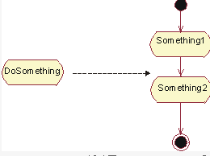
3) 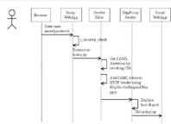
4) 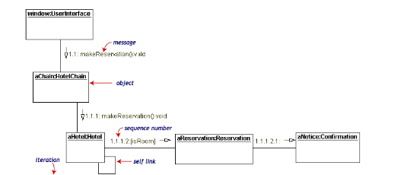
5) 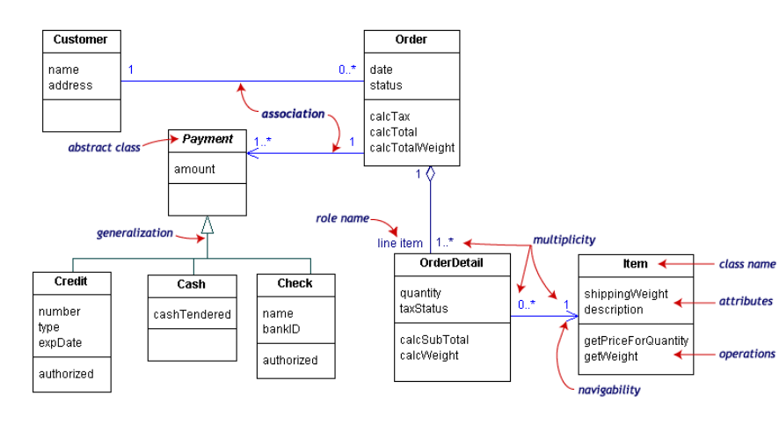
6) 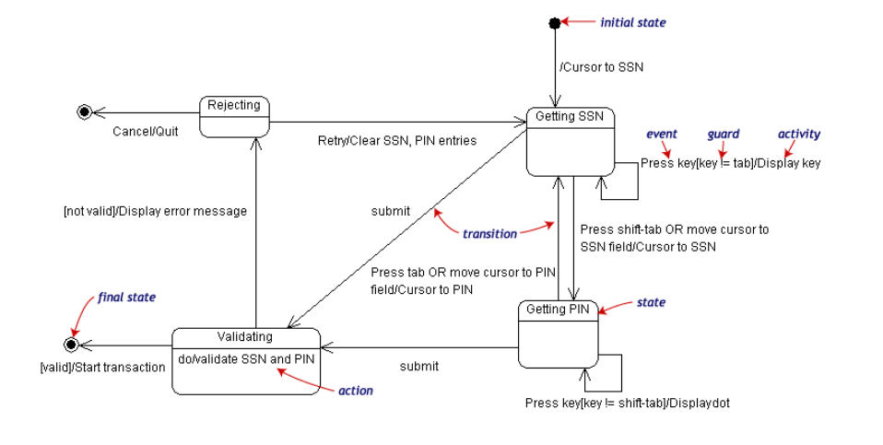
7) 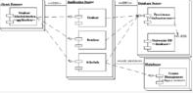
- Describe the similarities and differences between the sequence diagram and collaboration diagram.
They are both interactive diagram, but collaboration diagram don’t care about when the information be transferred.
- Define the different relationships in class diagram: dependency, association, aggregation, composition, generalization.
Dependency, is a connection during two classes, one class depend another class.
Association, it let a class acquire another class’s functions and attributes.
Aggregation, it is the association but those two classes are in different levels, one is entity but the other one is part.
Composition, it is a kind of aggregation, it demands the object that represent the entity in responsible of the life cycle of the object that represent the part.
Generalization, it represents the hierarchy between two classes.

- What is a node in deployment diagram? List two different types of nodes.
Node in deployment diagram always represent a device .

- Describe the extensibility mechanisms of UML.

- What is the function of Stereotypes？Give two examples of stereotypes.

- Explain the six best practices of software engineering.
- Iteration 2)Manage requirements 3)Module-basis architecture 4)visualization modeling
5) software quality’s confirmation 6)Control the changes of software.

- What is RUP? How many phases are there in RUP? Describe each phase’s purpose and milestone.
It is a programming exploitation methodology which is OOT and web-basis.
Inception, Elaboration, Construction, Transition
Inception: Constructing the business cases of system and confirm the edge of the project.
Lifecycle objective.
Elaboration: Analysis the problem domain.
Lifecycle architecture.
Construction: Product’s exploitation.
Initial operation.
Transition: Ensuring the software is usable to the customer.
Product release.

- Name and briefly describe the “4+1”views of architecture.
Ans:Which of the four views are:Logical View which is the logical relationship around the objects,Process View which is the view that show the actions of the objects or software actions,Deployment View which is to show the relatonship between the module of the objects and Implementation View which is the software implementations.And the one view can be Use-Case View.
- What is the difference between analysis and design?
The analysis focus on understanding of de problem,but the design focus on the understanding of the solution.
- Please describe the whole process of OO analysis and design with UML.
Ans:
- Build the requirement model-the plan for the reqiurement
- Build the basic model-Class diagram
- Build the assistant diagram
- Design the protocol of the model
- Prototype Development
- What is a layered architecture? Give examples of typical layers.
Ans: A layered architecture can be descript as the “separation of responsibility which is to say that each layer is responsible for a finite amount of work.For instance,a company may has its enterprise architecture.The layers of the manager and the layers of the employees.They have the responsibilities themselves and they have their own layers.
- What are analysis mechanisms? What are design mechanisms? Give examples.
Ans:Analysis mechanisms can be a process which may run through the whole analysis.And so does the design mechanisms.For instance,a analysis mechanisms may contains Auditing, Communication and so on.
- What is an analysis class? Name and describe the three analysis stereotypes. Give examples.
Boundary Classes: Behavior that involves communication with an actor
Entity Classes: Behavior that involves the data encapsulated within the abstraction
Control Classes: Behavior specific to a use case or part of a very important flow of events
- What is Use-case realization? What‘s your understandings about the benefit of the use-case realization structure.
Ans:The Use-case realization is a method to realize the problem that we should analyse. The use-case realization structure helps to organize the model elements needed to realize the use cases in the design model.

- Describe the steps occurred in the use-case analysis.
Ans:It may contain five steps: (1)Identify Use Cases,(2)Indentify Domain Class and relationships,(3)Define the System Sequence Diagram for each use case,(4)Produce an operation,(5)Draw a sequence diagram for each use case.

- What’s the package, and why we need package?
Ans:Package is a universal mechanism that organize other elements of the models together.
Why we need?If a system has a lot of structures and we have to know more about the structures,then we should point to the so many elements that the systems or the structures have.And at that time we can find that this may big a complex and hard work.So the package has been developed for this. Package is a universal mechanism that organize other elements of the models together.So we can analyse the system from the bigger layers instead of the great number of the element.
- What is a subsystem? What is an interface? How does a subsystem differ from a package?
Ans: A subsystem is a coherent and somewhat independent component of a larger system.It is an element of the model,and it contains the semantics of the packages and the classes.An interface can be an operation about the subsystem.A subsystem realizes one or more interfaces that define its behavior.
- What is the purpose of describing the run-time architecture? How to model the process view?
Ans:
Describing the run-time architecture’s purpose is:
Analyze concurrency requirements,Identify processes and threads,Identify process lifecycles, Map processes onto the implementation and Distribute model elements among
Processes.
The Process View is an “architecturally significant” slice of the
processes and threads of the Design Model.
Processes can be modeled using:
1. Active classes (Class Diagrams) and Objects(Interaction Diagrams) 2.Components (Component Diagrams)
- What is the purpose of describing the distribution? How to model the deployment view?
Ans:The purpose is to Reduce processor load.For the Special processing requirements,Scaling concerns,Economic concerns and Distributed access to the system.
The Deployment View is an “architecturally significant” slice of the Deployment Model.
The deployment view will contain nodes and connections.Connection lines are used to connect the nodes that will be Physical run-time computational resource, Processor node and Device node.And connections may contain Communication mechanism,Physical medium and Software protocol
- Describe the 3 typical distribution patterns, C/S , B/Sand P2P.
Ans:C/S:Client/Server, in network connections pattern, besides coordinated net, but also has another form network, namely client/server net, Client/Server. In the client/server network, the server is the network core, but the client is the network foundation, the client dependence server obtains the network resource which needs, but the server provides the network for the client to resources.
B/S: Browser/Server,is called as Browser/Server patterns.It is developing as the development of Internet,it is improved from the C/S.
P2P: Peer-to-peer network. According to the network in the shared resource way's difference, the local area network has two kind of configurations of organization: One kind is the peer-to-peer network (), another kind is the workstation/server structure. Between peer-to-peer network's computer may correspond mutually and the shared resource (document, peripheral device and so on); But in the workstation/server structure's network may the shared resource place on special purpose computer - server (server), between workstation not mutually direct shared resource.
- What is the difference between the process models of agile and RUP?
Ans: Rational Unified Process is a whole software process,but the process models of agile may be a process in an Architecture or in part of a software.That is to say the RUP may contain the process models of agile.

